Small quantity

🧂 What Is Small Quantity (as a Quantifier)?
# Source: AI Source: Provided by: [Data Path: Persons Table -> ID Column: 1, Name_En Column: Motasem Essam] -> From: [ChatGPT] on [7/28/2025]
Small quantity quantifiers are used to show that only a little or few of something exists — not much or not many.
They help express limited amount or number.

✅ Common Small Quantity Quantifiers
# Source: AI Source: Provided by: [Data Path: Persons Table -> ID Column: 1, Name_En Column: Motasem Essam] -> From: [ChatGPT] on [7/28/2025]
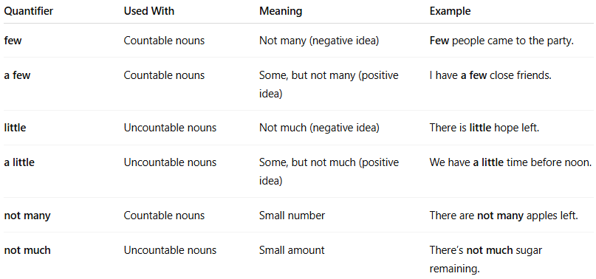
Quantifier | Used With | Meaning | Example
few | Countable nouns | Not many (negative idea) | Few people came to the party.
a few | Countable nouns | Some, but not many (positive idea) | I have a few close friends.
little | Uncountable nouns | Not much (negative idea) | There is little hope left.
a little | Uncountable nouns | Some, but not much (positive idea) | We have a little time before noon.
not many | Countable nouns | Small number | There are not many apples left.
not much | Uncountable nouns | Small amount | There’s not much sugar remaining.

📌 Key Differences:
# Source: AI Source: Provided by: [Data Path: Persons Table -> ID Column: 1, Name_En Column: Motasem Essam] -> From: [ChatGPT] on [7/28/2025]
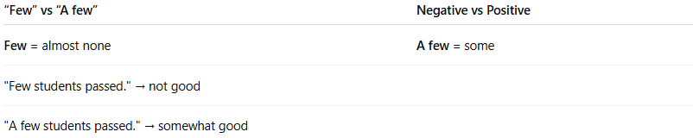
“Few” vs “A few” | Negative vs Positive
Few = almost none | A few = some
"Few students passed." → not good
"A few students passed." → somewhat good

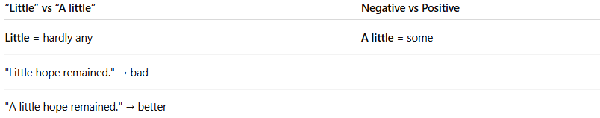

“Little” vs “A little” | Negative vs Positive
Little = hardly any | A little = some
"Little hope remained." → bad
"A little hope remained." → better

🧠 Summary
# Source: AI Source: Provided by: [Data Path: Persons Table -> ID Column: 1, Name_En Column: Motasem Essam] -> From: [ChatGPT] on [7/28/2025]
Countable | Uncountable
few / a few | little / a little

